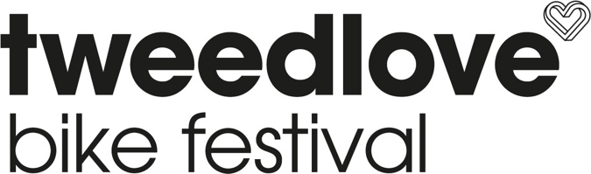

TweedLove Festival Campsite Fri 14th June – Mon 17th June 2024.

Terms & conditions
We ask all of our campers to comply with our policies otherwise we may have to ask you to leave the site.
- * Camping pitches and parking spaces are allocated on a first come, first served basis.
- * One pitch per tent (with vehicle), van or motorhome.
- * Toilet facilities are available.
- * No electric hook up available.
- * Please note there’s no gazebos/ezups allowed due to wind/safety considerations.
- * Strictly no open fires, no BBQ’s and no naked flames.
- * No noise in the camping field after 23:00.
- * Vehicle movement on the site is prohibited between 22:00 and 07:00.
- * Speed limit is 5mph in the camping field.
- * Under 16s must be supervised by a responsible adult
- * Dogs are allowed but must be on a lead at all times. You must clean up after them.
- * The organisers are not responsible for any misplaced, lost or stolen items.
- * Fire extinguishers are located at the gate of the camping field.
- * Campers are expected to behave in a manner that is courteous to other campers at all times.
- * Please consider other users of the site and we ask that all users always conduct themselves with due regard to the health and safety of themselves and others.
- * Please leave your camping pitch free of any litter.
- * In the event of poor ground conditions, a pitch may not be available. The Event Organisers will endeavour to advise you in advance should this occur but no responsibility can be accepted if this is not possible.
- * You can park one vehicle per pitch.
- * Max 2 people per pitch, under 16s free and can stay with family.
- *. Follow entrance and exit signs.
- * Bad behaviour will result in being asked to leave the campsite.
- * The Event Organisers will not accept responsibility for any loss or damage to the property of the visitor, including personal belongings, cash, jewellery, bicycles and motor vehicles, however, caused during their camping stay.
- * Leave your pitch as you find it, respect the environment, littering is frowned upon
- * You can bring alcohol, but please be responsible and respect others.

